**Chapter 2 - Blood Circulatory System**

**All Lectures Uploaded on YouTube:**

[**https://tinyurl.com/fkm10-biology**](https://tinyurl.com/fkm10-biology)

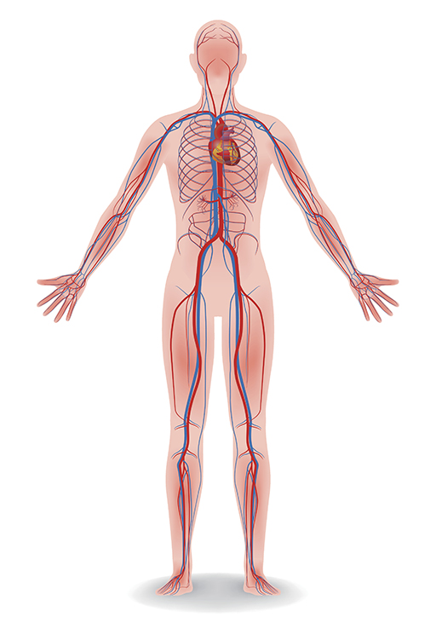

All the cells of our body need food from the small intestine and oxygen from our lungs. Our bodies are too large for materials to simply diffuse in and out. So we have a system of internal transport, a circulatory system that transports gases, nutrients and waste products. The heart and blood vessels make up the circulatory system.

**2.1. Organs Connected to Blood Circulatory System**

#### **Blood Circulation:**

* The body needs oxygen from the lungs and nutrients from the small intestine.
* Carbon dioxide and other waste materials are removed via the blood.
* The circulatory system **transports gases, nutrients, and waste**.
* The **heart pumps blood** through **arteries and veins,** forming the **cardiovascular system**:
  + **Cardio** = heart
  + **Vascular** = blood vessels

### **Blood Vessels**

* All body organs are connected to the circulatory system, including the head and neck, heart, liver, intestines, kidneys, arms, and legs.

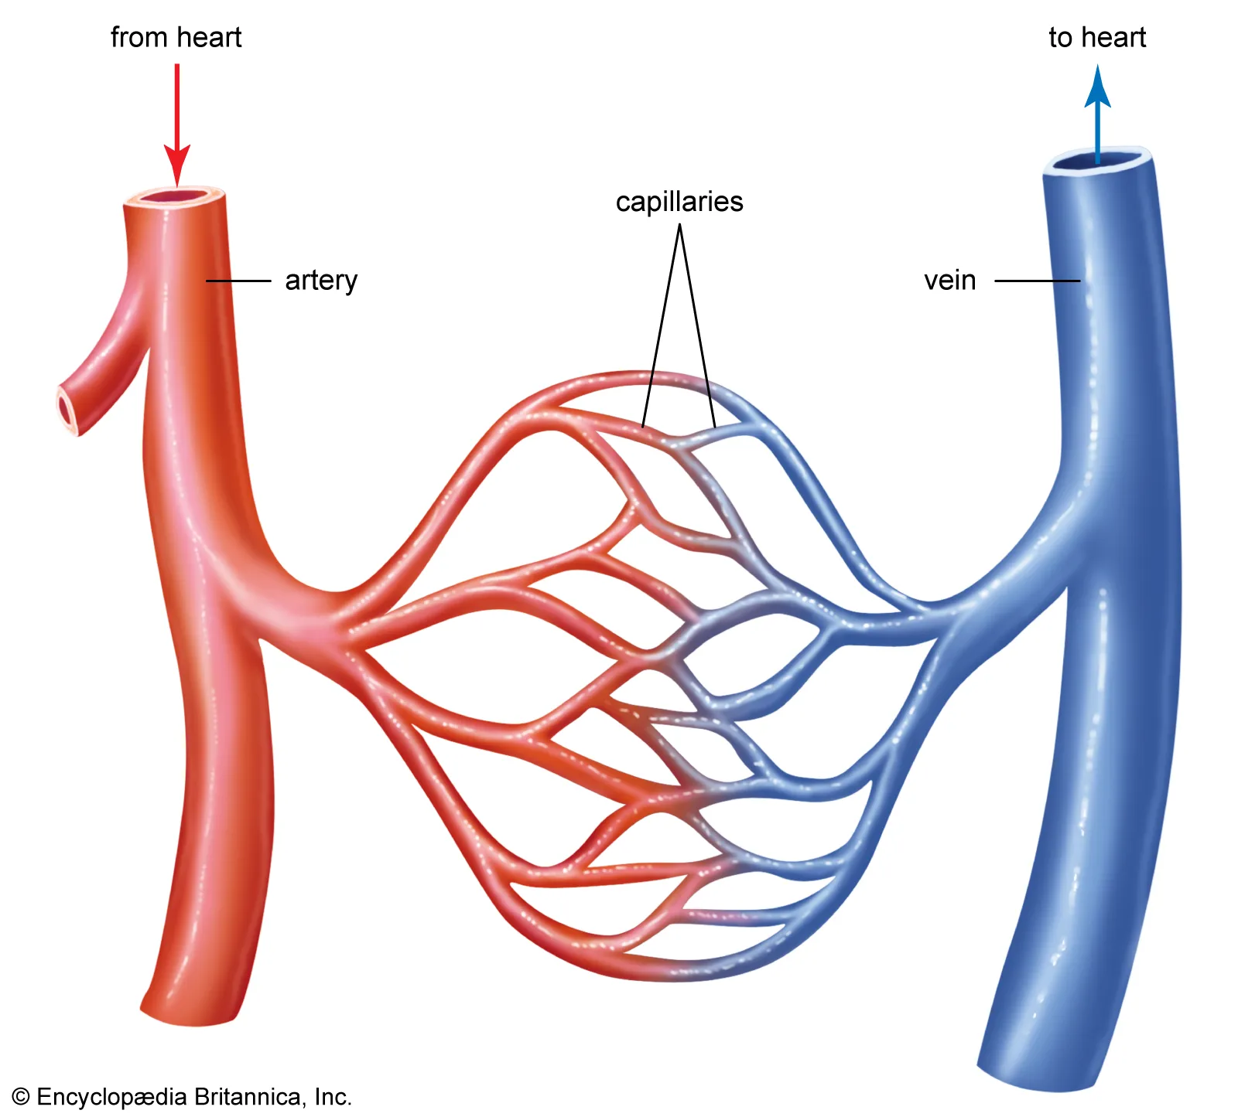

#### **Function:**

* Deliver oxygen and nutrients
* Remove carbon dioxide and waste

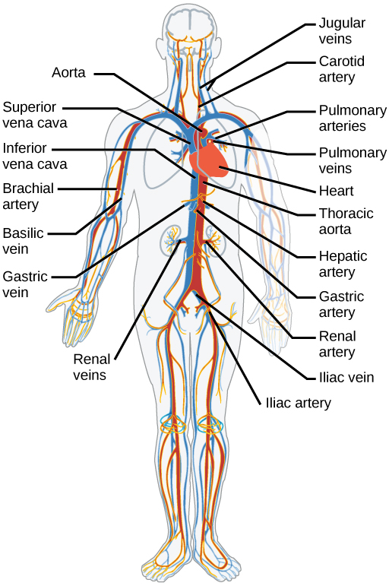

#### **Types of Blood Vessels:**

1. **Arteries**:
   * Thick, muscular walls
   * Carry oxygen-rich blood *from* the heart
   * Main artery: **Aorta**
   * **Arteries - away from the heart**
2. **Arterioles**:
   * Smaller branches of the arteries
   * Flexible walls
   * Adjust the size to regulate blood pressure and flow
3. **Capillaries**:
   * Tiny, thin-walled vessels
   * Allow exchange of **oxygen**, **nutrients**, **carbon dioxide**, and **waste**
   * Connect arterioles to venules
4. **Venules**:
   * Collect blood from capillaries
   * Gradually merge into veins
5. **Veins**:
   * Carry deoxygenated blood *to* the heart
   * Thinner walls than arteries
   * Have valves to prevent backflow
   * Veins - towards the heart

## **2.2. Components Of Blood**

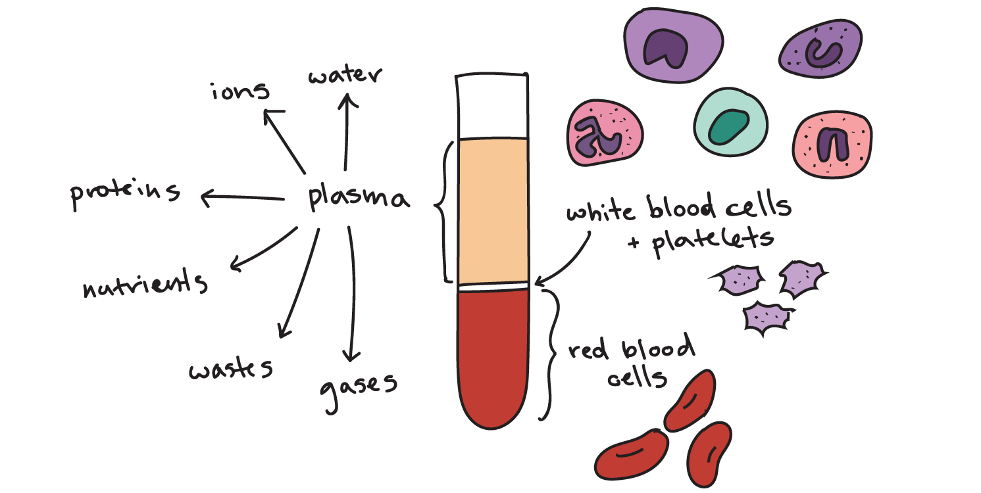

* Blood is a **special connective tissue** with **cells suspended in plasma**
* Transports nutrients, gases, hormones, and waste

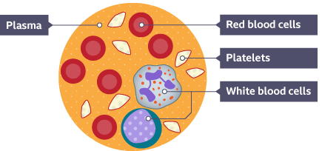

### **Two Main Components:**

1. **Plasma** (55% of blood volume)
2. **Blood cells** (RBCs, WBCs, platelets – not included in the current image)

**Plasma – The Liquid portion of blood**

* 90% Water, 10% Dissolved substances

**Substances in Plasma:**

1. **Plasma Proteins (7-9%)**
   * **Fibrinogen** – blood clotting
   * **Immunoglobulins (Antibodies)** – defence against disease
   * **Albumins** – maintain osmotic pressure
2. **Mineral Ions**
   * Chlorides, bicarbonates, sodium, potassium, calcium
3. **Metabolites and Wastes**
   * Amino acids, glucose, lipids, and vitamins
   * Urea, uric acid, carbon dioxide
4. **Hormones**
   * All are carried in the plasma
5. **Dissolved Gases**
   * Oxygen and carbon dioxide

### **2.3. Cell Types Found in Blood**

#### **a. Red Blood Cells (RBCs) / Erythrocytes**

* Circular, biconcave discs
* Contains **haemoglobin** (the iron-containing pigment that binds oxygen)
* Life span: **120 days**
* Produced in the **bone marrow**

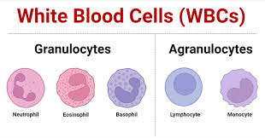

#### **b. White Blood Cells (WBCs) / Leukocytes**

* Lifespan: **3–4 days**
* Irregularly shaped, containing a nucleus
* Divided into:

**1. Granular Leukocytes:**

**Types:**

1. Neutrophils (phagocytose pathogens)
2. Basophils (release histamine during inflammation)
3. Eosinophils (involved in allergic responses)

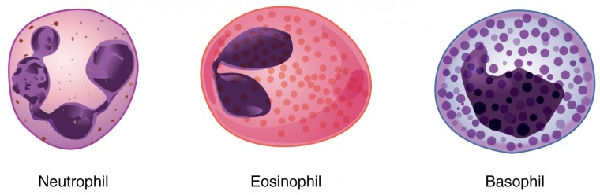

**2. Agranular Leukocytes:**

**Types:**

1. Monocytes (phagocytosis of large molecules and debris)
2. Lymphocytes (T-cells destroy infected cells; B-cells make antibodies)

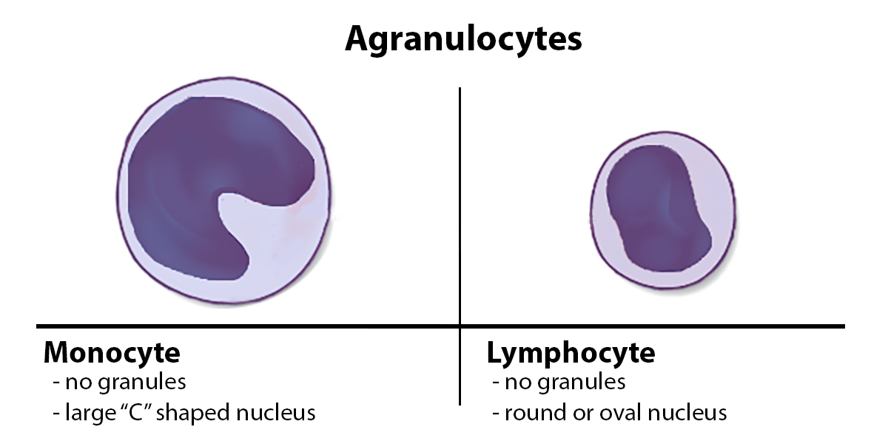

**c. Platelets**

* Small, disc-shaped cell fragments
* Help in **blood clotting**
* Form plugs at injury sites

### **Blood Clotting (Coagulation)**

* Prevents blood loss during injury.
* Involves **platelets** and **plasma proteins** (thrombin, fibrinogen).

#### **2.4. Steps of Blood Clotting:**

1. **Injury** → Collagen exposed, platelets activated
2. **Constriction** → Vessel narrows to reduce blood flow
3. **Platelet Activation** → Releases chemicals to attract more platelets
4. **Platelet Plug Formation** → Platelets stick together
5. **Release of Clotting Factors** → From injured tissue and platelets
6. **Fibrin Clot Formation** → Fibrin mesh traps cells, forming a stable clot
7. **Fibrin Clot** → Stops blood loss, blocks pathogen entry

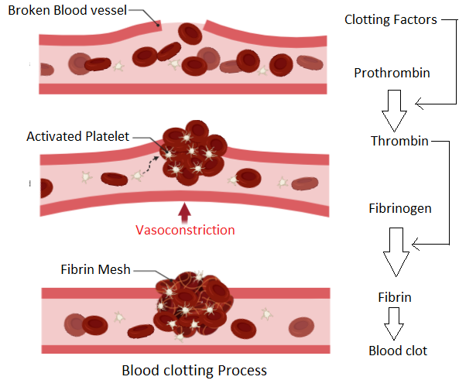

### **2.5. Heart**

* Located between the lungs, above the diaphragm.
* Size of a fist, **7–15 ounces**.
* Surrounded by the **pericardium**, a fluid-filled sac reduces friction.
* Has three layers:
  1. **Endocardium** (inner)
  2. **Myocardium** (muscular, thickest)
  3. **Pericardium** (outer)

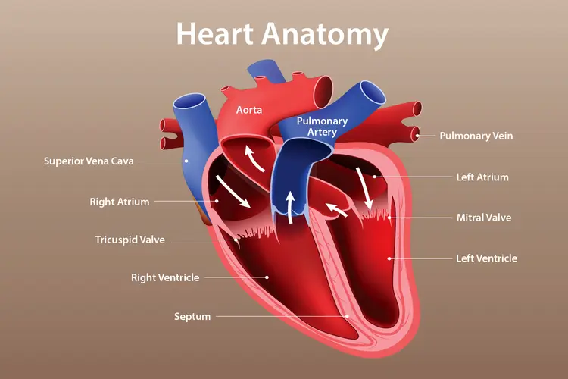

### **2.5.1. The Heart Chambers**

* Divided into **4 chambers**:
  + **Atria (Upper):** Right atrium & Left atrium
  + **Ventricles (Lower):** Right ventricle & Left ventricle

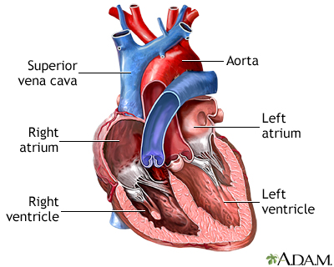

**Right Atrium:**

* Receives **deoxygenated** blood from the body via the superior & inferior **vena cava**

**Right ventricle:**

* Pumps blood to the lungs via the **pulmonary artery**

**Left Atrium:**

* Receives oxygenated blood from the lungs via the **pulmonary veins**

**Left Ventricle:**

* Pumps oxygenated blood to the body via the **aorta**
* Ventricles have thicker walls than atria.
* The left ventricle has the thickest wall to pump blood throughout the body.

**2.5.2. The Heart Valves**

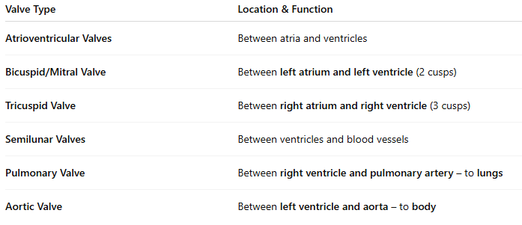

#### **Flow of Blood:**

* **Deoxygenated blood** from the body → Right atrium → Tricuspid valve → Right ventricle → Pulmonary artery → Lungs
* **Oxygenated blood** from lungs → Left atrium → Bicuspid valve → Left ventricle → Aorta → Body

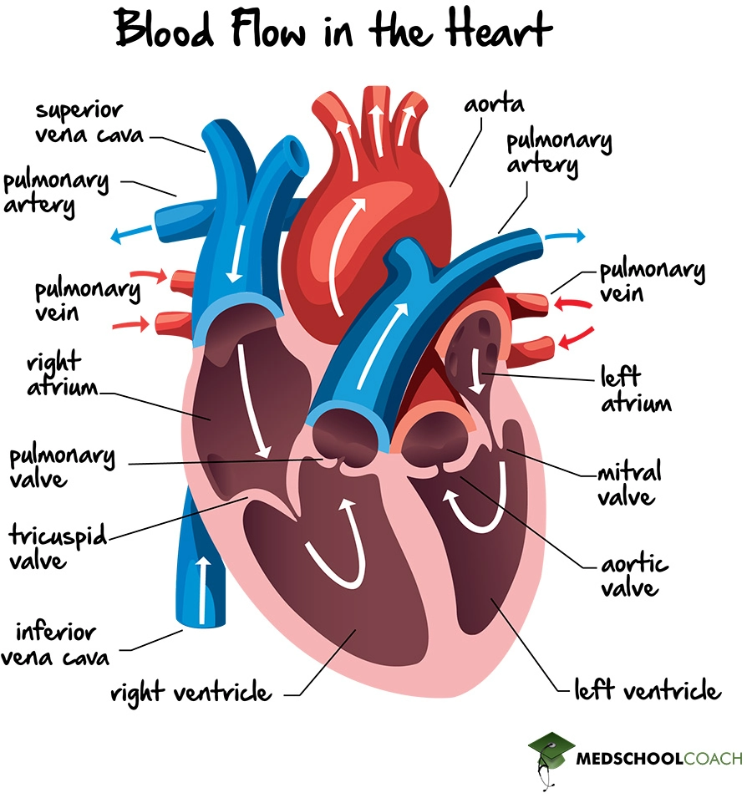

### **Passage of Blood Through the Heart**

* **The right side of the heart:**
  + **The right atrium** receives deoxygenated blood from the **vena cava**.
  + Blood flows to the **right ventricle** → contracts → pushes blood through the **pulmonary trunk**.
  + The pulmonary trunk divides into **pulmonary arteries,** → carry blood to the lungs.
  + Pulmonary arteries contain **semilunar valves** to prevent backflow.
  + In the lungs, gas exchange takes place; **oxygenated blood** returns to the heart via **pulmonary veins** to the **left atrium**.
* **The left side of the heart:**
  + Blood from the left atrium enters the **left ventricle** via the **bicuspid (mitral) valve**.
  + The left ventricle contracts and pumps blood into the **aorta**, the largest artery.
  + The aorta has **semilunar valves** to prevent backflow.
  + Oxygenated blood is distributed to **all body parts** except the lungs.
* **Differences:**
  + **The right ventricle** pumps blood at low pressure to the lungs.
  + The **left ventricle** pumps blood at high pressure to the rest of the body (e.g., arms, legs).
  + Pulmonary circulation has **low pressure**, the systemic circulation has **high pressure**.

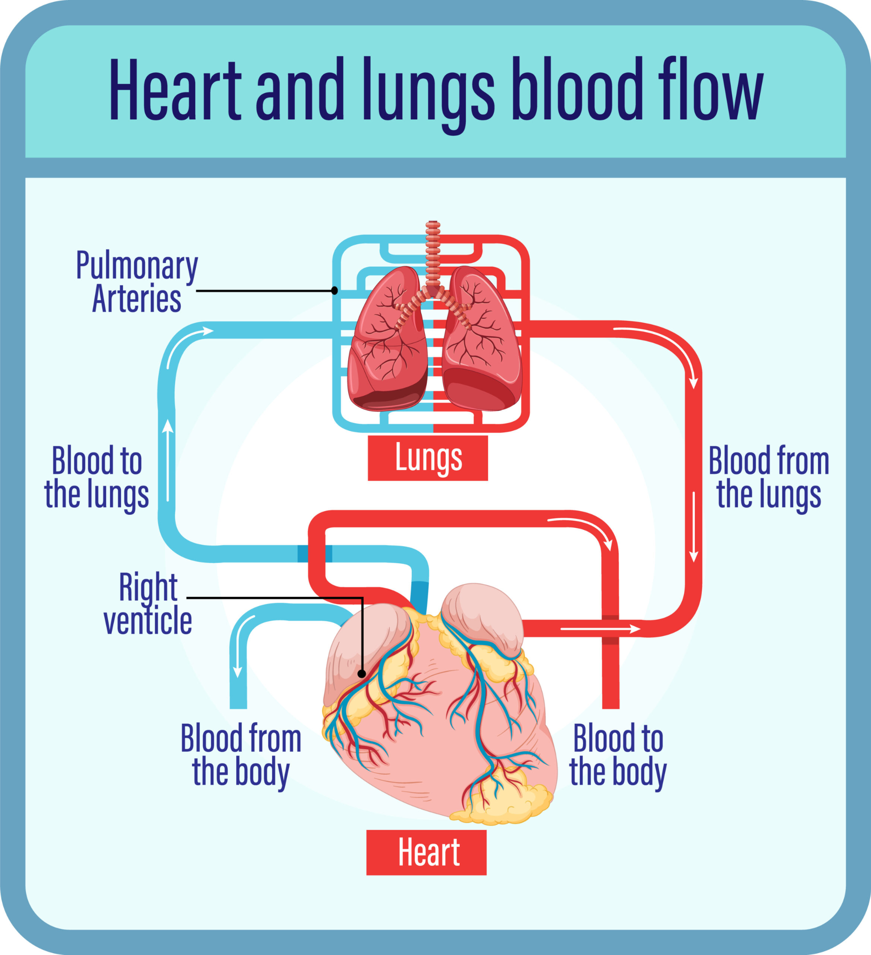

### **Arterial System**

* **Function:** Supplies oxygenated blood from the heart to various organs.
* **Major Arteries:**
  + **Coronary arteries** – Heart itself.
  + **Carotid arteries** – Head and neck.
  + **Subclavian arteries** – Shoulders and arms.
  + **Dorsal aorta** – Runs along the back.
* **Branches of Dorsal Aorta:**
  + **Hepatic artery** – Liver.
  + **Gastric artery** – Stomach.
  + **Renal arteries** – Kidneys.
  + **Common iliac arteries** – Each leg.

### **Venous System**

* **Function:** Returns deoxygenated blood from the body back to the heart.
* **Main Veins:**
  + **Jugular veins** – Head and neck.
  + **Subclavian veins** – Shoulders and arms.
  + **Superior vena cava** – Upper body to the heart.
  + **Common iliac & femoral veins** – Lower limbs.
  + **Renal veins** – Kidneys.
  + **Hepatic veins** – Liver and digestive system.
  + **Inferior vena cava** – Lower body to heart.
* **Hepatic Portal Vein:**
  + Collects blood from the digestive system and sends it to the liver before entering the heart.
  + Blood is filtered in the liver via capillaries before entering circulation.
* There are approximately **160 km of blood vessels** in the body, producing **a billion red blood cells every day**.

### **2.6. Circulation of Blood**

Blood circulates through **three main circuits**:

#### **A. Pulmonary Circulation:**

* Right side of heart → lungs → left side of heart.
* Transports **deoxygenated blood to the lungs** and returns **oxygenated blood to the heart**.

#### **B. Systemic Circulation:**

* Left side of heart → entire body → right side of heart.
* Transports **oxygenated blood to the body tissues** and returns **deoxygenated blood**.

#### **C. Coronary Circulation:**

* Supplies **blood to the heart muscles** themselves via the **coronary arteries**.

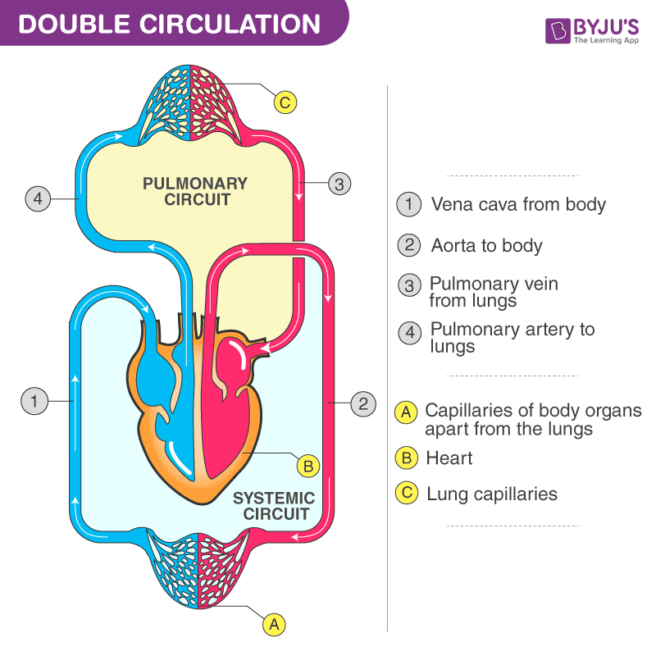

### **2.7. Transportation of Material Through Blood**

#### **Main Functions of Blood:**

1. **Transport of Digested Food:**
   * Nutrients like glucose, amino acids, and vitamins are absorbed from the intestines into cells.
2. **Transport of Oxygen:**
   * Carried by **red blood cells** containing **haemoglobin**.
   * Each haemoglobin binds 4 oxygen molecules to form **oxyhaemoglobin**.
3. **Transport of Carbon Dioxide:**
   * Removed from cells and carried back to lungs in 3 forms:
     + **Bicarbonate ions (HCO₃⁻)** – the majority.
     + **Carbaminohaemoglobin** – bound to haemoglobin.
     + **Dissolved in plasma** – small amount.
4. **Transport of Excretory Wastes:**
   * Waste like urea is filtered through the kidneys.
   * Reabsorption of useful substances occurs in nephrons.
5. **Transport of Hormones:**
   * Carried from endocrine glands to **target cells**.
   * Hormones act on specific cells with **receptors**.

### **2.8. Common Heart Diseases**

### **2.8.1. Coronary Heart Diseases**

* **Arteriosclerosis**: Hardening of the arteries due to ageing or other factors.
* **Atherosclerosis**: Accumulation of materials, especially cholesterol, in the arterial walls, forming **plaques**.
  + These **plaques** narrow the arteries and can block blood flow.
  + Plaques may form **clots** on the irregular artery walls:
    - **Thrombus**: A stationary clot.
    - **Embolus**: A clot that breaks off and travels to block another artery.
* **Rupture and Haemorrhage**:
  + Hardened arteries lose elasticity and may rupture, leading to **haemorrhage** (internal bleeding).

### **2.8.2. Myocardial Infarction (Heart Attack)**

* **Cause**: Embolus or plaque blocks a coronary artery.
* **Effect**: Oxygen supply to the heart muscle is cut off, leading to **death of the heart muscle tissue**.
* **Infarction**: Tissue death due to lack of oxygen.
* **Term**: The entire process is known as **myocardial infarction**.

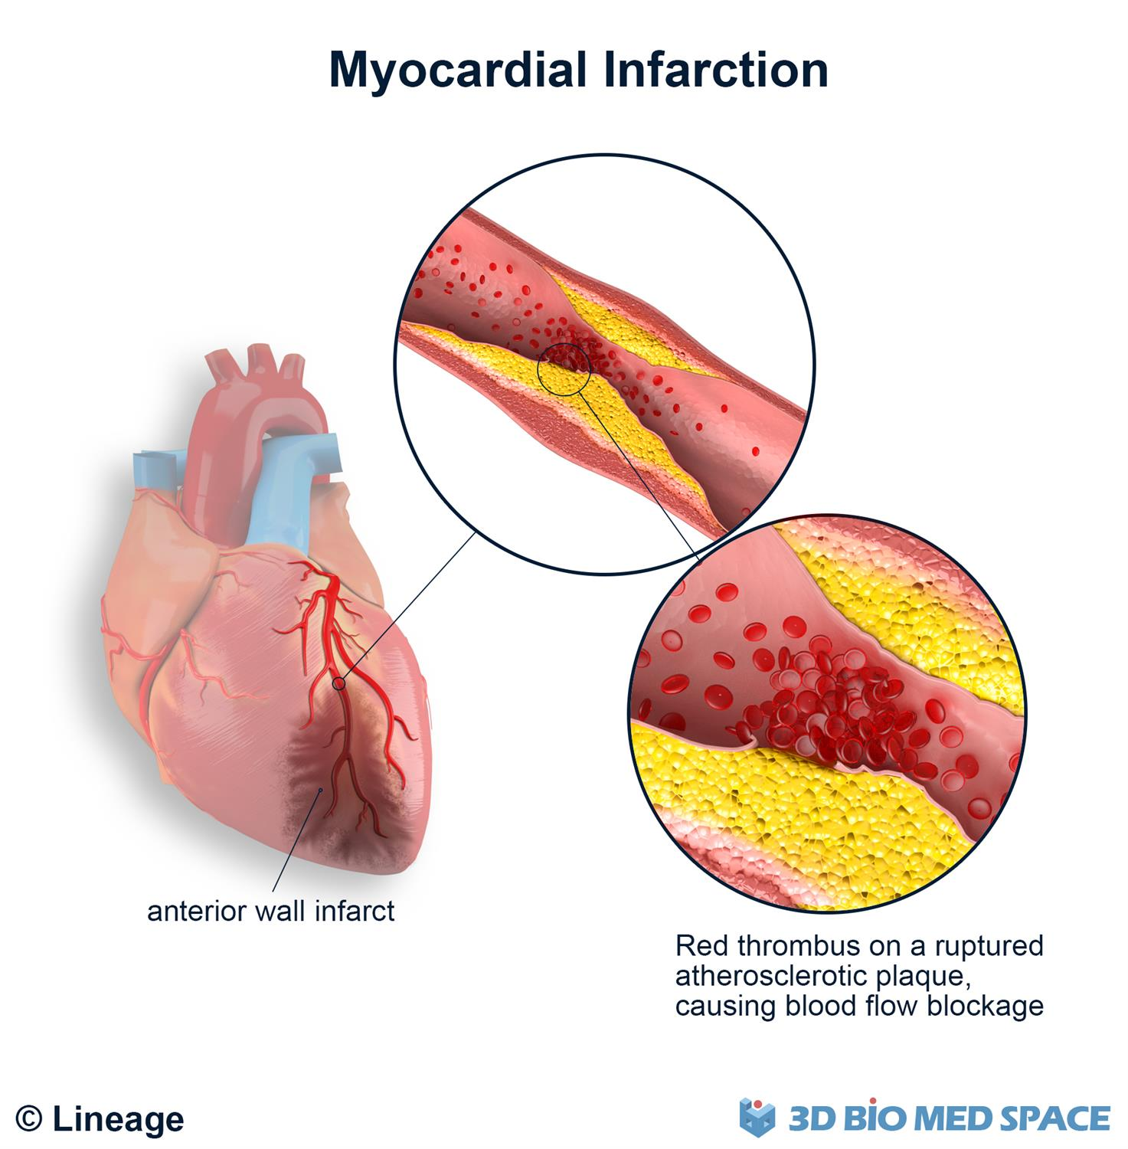

#### **Treatment:**

1. **Medical Treatment**:
   * Use of **enzymes** to dissolve clots.
2. **Coronary Bypass Surgery**:
   * A **grafted blood vessel** from elsewhere in the body is used to bypass the blocked artery.
3. **Angioplasty**:
   * A **mechanical widening** of narrowed/blocked coronary arteries.

### **Prevention of Coronary Heart Diseases:**

1. Avoid high salt and fatty foods.
2. Maintain a healthy body weight.
3. Control blood pressure.
4. Exercise regularly.
5. Avoid smoking.
6. Manage and reduce stress.

### **2.8.3. Angina**

* **Definition**: Chest pain or discomfort due to insufficient oxygen-rich blood reaching the heart.
* **Cause**: Increased demand for blood by the heart with restricted supply.
* **Nature**: Not a disease but a **symptom and warning sign** of heart disease.

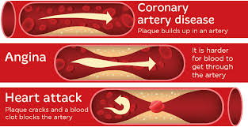

#### **Symptoms of Angina:**

* Fatigue
* Nausea or vomiting
* Shortness of breath
* Sweating
* Chest pain or discomfort

### **2.9. Harmful Effects Of Smoking On The Heart**

* **General Effects**:
  + Damages the heart and blood vessels.
  + Speeds up the **narrowing and clogging** of coronary arteries.
  + Reduces blood flow to the heart.
  + Increases the risk of **heart attack** and **stroke**.

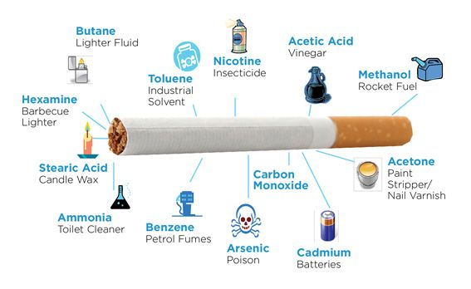

#### **Tobacco Smoke Contains:**

1. **Nicotine**:
   * An **addictive drug**.
   * Affects the brain and muscles.
   * Raises **blood pressure**.
   * Makes the **heart work harder**.
2. **Carbon Monoxide**:
   * A **poisonous gas**.
   * Replaces **oxygen** in the blood.
   * Reduces oxygen supply to heart and other organs.
   * Smokers have:
     + Over **2x risk** of heart attacks.
     + Over **2x risk** of strokes compared to non-smokers.



